

**Marketing Research Project**

**MKTG8005 – Applied Marketing Research**

**Assessment 3 – Data Analysis and Reporting**

**Submitted by**

Raj Katare

Student Id: 46843302

Master of Business Analytics

Macquarie University

**Introduction:**

Due to the increase in the growth of tourism industry, the role of data analysis in the tourism industry too is becoming increasingly important with every passing year. Data analysis opens various opportunities for travel companies as it helps in reviewing and understanding large volumes of data quickly.

Through the travel data provided, this research model will comprise of analyzing the data and report the findings on the relationship between them. The data contains a total of 134 entries. To study the research model, there are 6 variables involved to understand these relationships for the research model. These variables consist of a few aspects which define them. They are as follows:

1. **Perceived well-being (WB)**

**WB1:** This event met my overall well-being needs.

**WB2:** This event played a very important role in my social well-being.

**WB3:** This event played an important role in my travel well-being.

**WB4:** This event played an important role in enhancing my quality of life.

1. **Special Event Prestige (PRE)**

**PRE1:** This event is a very prestigious event.

**PRE2:** This event is one of the best special events for culture.

**PRE3:** This event is a first-class, high-quality tourism special event.

1. **Involvement in special events (INV)**

**INV1:** I am very interested in anything related to special event tourism.

**INV2:** Which tourism special events I attend matters a lot.

**INV3:** I value tourism special events as an important part of my life.

**INV4:** Tourism special events means a lot to me.

1. **Overall Experience (EX)**

**EX1:** I will have a lot of memorable experiences about this event.

**EX2:** Thinking of this event will bring back good memories.

**EX3:** I will have fond memories of this event.

1. **Word of Mouth (WOM)**

**WOM1:** I like recommending this event to other people.

**WOM2:** I love to talk about the good points of this event to people I know.

**WOM3:** I have managed to convince other people to attend this event.

1. **Social Media Engagement (SM)**

**SM1:** I used social media to interact with friends about this event.

**SM2:** social media provided a way for me to stay connected to people across distances.

**SM3:** I used social media to tell others about this event.

**SM4:** I posted/shared photos/videos for friends/family and acquaintances, on social media (e.g., Facebook).

**SM5:** I wanted to inspire other people about this event with my social media posts.

**SM6:** I liked to share my impressions about this event through social media.

**SM7:** It made me feel accepted when people commented on my social media posts.

The graphical representation of the relationship between these variables is as follows:

**Dealing with the missing values and outliers:**

Here, the missing values and outliers will be dealt with to avoid the data being biased. In the case of outliers, the outliers will be replaced with blanks so that they are treated equally as the missing values in the further steps. Furthermore, if the variables which contain the missing values are not scalable, the rows of the missing values will be deleted. On the other hand, if the values are scalable, the missing values will be replaced with the mean of the values of the corresponding variable.

In the case of the 6 variables, all the values are scalable and range from 1 to 7. Hence, any value apart from these values will be treated as missing values and will be replaced with the mean of the values of the corresponding variable. If the mean value is not a whole number, the missing values will be replaced with the closest whole number of that mean value.

1. **Perceived well-being (WB)**

In the above statistics, the variable WB4 contains a missing value. We can also observe that the maximum value for WB4 variable is 11 which is an outlier. The location of the outlier can be known from the table below:

1. **Special Event Prestige (PRE)**

In the above statistics, there is no missing value. But the maximum value for PRE3 variable is 66 which is an outlier. The location of the outlier can be known from the table below:

1. **Involvement in special events (INV)**

In the above statistics, the variable INV1 contains one missing value. We can also observe that the maximum value for INV1 variable is 44 which is an outlier. The location of the outlier can be known from the table below:

1. **Overall Experience (EX)**

In the above statistics, the variable EX3 contains 3 missing values. However, there is no outlier in the Overall Experience variable. Hence, it is not required to compute the table for the outliers.

1. **Word of Mouth (WOM)**

In the above statistics, the variable WOM2 contains 2 missing values. However, there is no outlier in the Overall Experience variable. Hence, it is not required to compute the table for the outliers.

1. **Social Media Engagement (SM)**

In the above statistics, the variables SM4 and SM6 contain 2 missing values and SM7 contains 1 missing value. We can also observe that the maximum value for SM4 variable is 52 which is an outlier. The location of the outlier can be known from the table below:

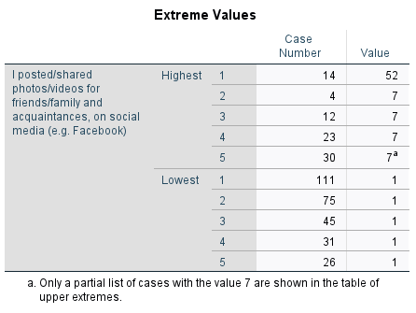

**Descriptive statistics construct:**

To understand the normality of the variables with the perspective of normal distribution, the descriptive statistics define the mean, skewness, and kurtosis of the variables.

The skewness needs to be between -1 and +1 and kurtosis needs to be between -3 to +3 for the data to demonstrate a normal distribution. The descriptive statistics can be computed as follows:

1. **Perceived well-being (WB)**

The results demonstrate Kurtosis and Skewness tests show that all 4 items are normally distributed, as all the indices fit between both skewness as well as kurtosis indicated intervals.

For the mean statistics:

There was an average of 3.91 responses to this item (WB1).

There was an average of 3.55 responses to this item (WB2).

There was an average of 3.75 responses to this item (WB3).

There was an average of 3.19 responses to this item (WB4_1).

This means most respondents had a **neutral** response based on perceived well-being.

1. **Special Event Prestige (PRE)**

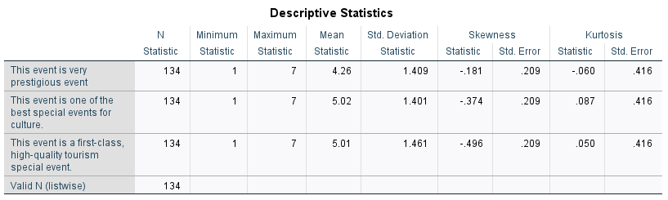

The results demonstrate Kurtosis and Skewness tests show that all 3 items are normally distributed, as all the indices fit between both skewness as well as kurtosis indicated intervals.

For the mean statistics:

There was an average of 4.26 responses to this item (PRE1).

There was an average of 5.02 responses to this item (PRE2).

There was an average of 5.01 responses to this item (PRE3).

This means the average response was **somewhat agreeable** based on Special Event Prestige.

1. **Involvement in special events (INV)**

The results demonstrate Kurtosis and Skewness tests show that all 4 items are normally distributed, as all the indices fit between both skewness as well as kurtosis indicated intervals.

For the mean statistics:

There was an average of 3.68 responses to this item (INV1_1).

There was an average of 3.88 responses to this item (INV2).

There was an average of 3.47 responses to this item (INV3).

There was an average of 3.43 responses to this item (INV4).

This means the average response was **neutral** based on Involvement in special events.

1. **Overall Experience (EX)**

The results demonstrate Kurtosis and Skewness tests show that all 4 items are normally distributed, as all the indices fit between both skewness as well as kurtosis indicated intervals.

For the mean statistics:

There was an average of 3.92 responses to this item (EX1).

There was an average of 4.20 responses to this item (EX2).

There was an average of 4.38 responses to this item (EX3_1).

This means the average response was **neutral** based on Overall Experience.

1. **Word of Mouth (WOM)**

The results demonstrate Kurtosis and Skewness tests show that all 4 items are normally distributed, as all the indices fit between both skewness as well as kurtosis indicated intervals.

For the mean statistics:

There was an average of 4.46 responses to this item (WOM1).

There was an average of 4.47 responses to this item (WOM2_1).

There was an average of 4.36 responses to this item (WOM3).

This means the average response was **somewhat agreeable** based on word of mouth.

1. **Social Media Engagement (SM)**

The results demonstrate Kurtosis and Skewness tests show that all 4 items are normally distributed, as all the indices fit between both skewness as well as kurtosis indicated intervals.

For the mean statistics:

There was an average of 4.32 responses to this item (SM1).

There was an average of 4.88 responses to this item (SM2).

There was an average of 4.38 responses to this item (SM3).

There was an average of 4.63 responses to this item (SM4_1).

There was an average of 4.07 responses to this item (SM5).

There was an average of 4.29 responses to this item (SM6_1).

There was an average of 4.25 responses to this item (SM7_1).

This means the average response was **neutral** based on Social Media Engagement variable.

**Preliminary Analysis:**

|  |  |  |  |  |  |
| --- | --- | --- | --- | --- | --- |
| **Constructs** | **Factor loadings** | **KMO** | **Cronbach alpha** | **CR** | **AVE** |
| **Perceived well-being (WB)** |  | 0.83 | 0.89 | 0.93 | 0.76 |
| WB1 | 0.82 |  |  |  |  |
| WB2 | 0.89 |  |  |  |  |
| WB3 | 0.89 |  |  |  |  |
| WB4 | 0.88 |  |  |  |  |
| **Special event prestige (PRE)** |  | 0.62 | 0.79 | 0.88 | 0.71 |
| PRE1 | 0.70 |  |  |  |  |
| PRE2 | 0.91 |  |  |  |  |
| PRE3 | 0.92 |  |  |  |  |
| **Involvement in Special Event (INV)** |  | 0.73 | 0.86 | 0.91 | 0.71 |
| INV1 | 0.86 |  |  |  |  |
| INV2 | 0.77 |  |  |  |  |
| INV3 | 0.87 |  |  |  |  |
| INV4 | 0.88 |  |  |  |  |
| **Overall experience (EXP)** |  | 0.74 | 0.90 | 0.94 | 0.84 |
| EX1 | 0.89 |  |  |  |  |
| EX2 | 0.94 |  |  |  |  |
| EX3 | 0.92 |  |  |  |  |
| **Word of mouth (WOM)** |  | 0.75 | 0.90 | 0.94 | 0.84 |
| WOM1 | 0.92 |  |  |  |  |
| WOM2 | 0.93 |  |  |  |  |
| WOM3 | 0.90 |  |  |  |  |
| **Social Media Engagement (SM)** |  | 0.85 | 0.89 | 0.92 | 0.62 |
| SM1 | 0.68 |  |  |  |  |
| SM2 | 0.62 |  |  |  |  |
| SM3 | 0.85 |  |  |  |  |
| SM4 | 0.86 |  |  |  |  |
| SM5 | 0.87 |  |  |  |  |
| SM6 | 0.86 |  |  |  |  |
| SM7 | 0.70 |  |  |  |  |

**Reliability**

The Cronbach alpha and CR are computed separately for brand consciousness and status consciousness and the scores are bigger than the threshold value (0.70). Hence, the result supports the reliability requirement of measures.

**Convergent Validity**

As observed from table above, all the factor loading values are above the threshold value (0.50) and load significantly on the related construct. Hence, it indicates that the measures used in the study have acceptable convergent validity.

To ensure convergent validity of measures, we have used extra validity tests and calculated the Average Variance Extracted (AVE) for each construct. As per the observation from the table above, the AVE of all constructs range between 0.62 to 0.84. This exceeds the threshold value of 0.5. These results support convergent validity.

**Interpretation through correlation:**

|  |  |  |  |  |  |  |  |  |
| --- | --- | --- | --- | --- | --- | --- | --- | --- |
| Correlations | Mean | Std. Deviation | Mean_WB | Mean_PRE | Mean_INV | Mean_EXP | Mean_WOM | Mean_SM |
| Mean_WB | 3.6 | 1.17 | 1 (0.87) |  |  |  |  |  |
| Mean_PRE | 4.76 | 1.2 | 0.469** | 1 (0.85) |  |  |  |  |
| Mean_INV | 3.61 | 1.27 | 0.505** | 0.433** | 1 (0.84) |  |  |  |
| Mean_EXP | 4.17 | 1.26 | 0.664** | 0.647** | 0.657** | 1 (0.92) |  |  |
| Mean_WOM | 4.43 | 1.4 | 0.304** | 0.450** | 0.419** | 0.461** | 1 (0.91) |  |
| Mean_SM | 4.4 | 1.15 | 0.2* | 0.06 | 0.08 | 0.02 | 0.13 | 1 (0.78) |

**NOTE:** The square root of AVEs have been reported on the diagonal

** Correlation is significant at the 0.01 level (2-tailed).

|r|<.10 correlation is very low.

.10<|r|<.20 correlation is low.

.20<|r|<.30 correlation is moderate.

.30<|r|<.50 correlation is high.

.50<|r|correlation is very high.

Correlation coefficient between WB and PRE is 0.47 which is high and significant at 0.01 level.

Correlation coefficient between WB and INV is 0.51 which is high and significant at 0.01 level.

Correlation coefficient between WB and EXP is 0.66 which is high and significant at 0.01 level.

Correlation coefficient between WB and WOM is 0.30 which is high and significant at 0.01 level.

Correlation coefficient between PRE and INV is 0.43 which is high and significant at 0.01 level.

Correlation coefficient between PRE and EXP is 0.65 which is high and significant at 0.01 level.

Correlation coefficient between PRE and WOM is 0.45 which is high and significant at 0.01 level.

Correlation coefficient between INV and EXP is 0.66 which is high and significant at 0.01 level.

Correlation coefficient between INV and WOM is 0.42 which is high and significant at 0.01 level.

Correlation coefficient between EXP and WOM is 0.46 which is high and significant at 0.01 level.

Correlation coefficient between WB and SM is 0.2 which is low but is significant at 0.05 level.

Correlation coefficient between PRE and SM is 0.06 which is very low and insignificant.

Correlation coefficient between INV and SM is 0.08 which is very low and insignificant.

Correlation coefficient between EXP and SM is 0.02 which is very low and insignificant.

Correlation coefficient between WOM and SM is 0.13 which is very low and insignificant.

**Interpretation:**

Discriminant validity was tested and the square root of the AVE of each construct was calculated. The square roots of all the AVEs were greater than the correlations between variables. This indicates **discriminant validity** for all constructs.

**Hypothesis:**

**H1:** There is a positive relationship between WB and INV

# H2: There is a positive relationship between PRE and INV

# H3: There is a positive relationship between INV and EXP

# H4: There is a positive relationship between EXP and WOM

# H5: There is a positive relationship between EXP and SM

|  |  |  |  |  |
| --- | --- | --- | --- | --- |
| Independent Variables | Model 1 | Model 2 | Model 3 | Model 4 |
|  | INV | EXP | WOM | SM |
| WB | 0.39 (4.70) |  |  |  |
| PRE | 0.25 (3.04) |  |  |  |
| INV |  | 0.66 (10.02) |  |  |
| EXP |  |  | 0.46 (5.97) | 0.02 (0.23) |
| R2 | 0.3 | 0.43 | 0.21 | 0 |

**Note:** t-values have been reported within the parenthesis

**R^2 interpretation scale:** R^2 ≤0.25 Weak, 0.25 ≤ R^2 ≤0.50 Moderate, 0.5 ≤ R^2 ≥0.75 Substantial

**Hypothesis 1**- H1 hypothesized that there is a positive relationship between WB and INV. As shown in the table, the findings **support** the hypothesis because |t-value| is **4.70** which is more than the cut-off point of 1.96 and p-value is **less than 0.01** which is also less than the cut-off point of 0.05. Also, beta coefficient is strong **(0.39)**.

**Hypothesis 2**- H2 hypothesized that there is a positive relationship between PRE and INV. As shown in the table, the findings **support** the hypothesis because |t-value| is **3.04** which is more than the cut-off point of 1.96 and p-value is **0.03** which is less than the cut-off point of 0.05. Also, beta coefficient is strong **(0.25)**.

**Hypothesis 3**- H3 hypothesized that there is a positive relationship between INV and EXP. As shown in the table, the findings **support** the hypothesis because |t-value| is **10.02** which is more than the cut-off point of 1.96 and p-value is **less than 0.01** which is also less than the cut-off point of 0.05. Also, beta coefficient is strong **(0.66)**.

**Hypothesis 4**- H4 hypothesized that there is a positive relationship between EXP and WOM. As shown in the table, the findings **support** the hypothesis because |t-value| is **5.97** which is more than the cut-off point of 1.96 and p-value is **less than 0.01** which is also less than the cut-off point of 0.05. Also, beta coefficient is strong **(0.46)**.

**Hypothesis 5**- H5 hypothesized that there is a positive relationship between EXP and SM. As shown in the table, the findings **do not** **support** the hypothesis because |t-value| is **5.97** which is more than the cut-off point of 1.96 but the p-value is **0.82** which is more than the cut-off point of 0.05. Also, beta coefficient is very weak **(0.02)**.

Multi-collinearity was checked by comparing the values of VIF with the threshold of 5. The VIF values were **less than 5** for the multiple independent variables, so there was no threat of multi-collinearity.

R-squared in the models are **0.55** and **0.66** for the models 1 and 2 respectively which is substantial.

For model 3, the R-squared value is **0.46** which is moderate.

For model 4, the R-squared value is **0.02** which is weak.

**Research question:**

**Hypothesis:** If female customers get involved with the special eventdifferently from male customers.

An Independent t-test was conducted to study the involvement of Females.

$$t_{value}\left(129\right) =0.707$$

$$n1=41$$

$$n2=90$$

**Regarding the effect size, the following results were established.**

$$η^{2}= \frac{t_{value}^{2}}{t_{value}^{2}+(n1+n2-2)}$$

$$η^{2}= \frac{{0.707}^{2}}{{0.707}^{2}+(41+90-2)} = 0.00386$$

$$η^{2}=0.0039$$

The results show that there was not statistically significance between the mean service quality test scores of males (n1=41, M=3.52, SD=1.32) and females (n2=90, M=3.69, SD=1.26), t(129) = -0.707, p-value=0.481.

Gender has no bearing on involvement because of the effect size, which is very minimal ($η^{2}=0.004$).

In conclusion, we disprove the idea that women get more involved with special event.

**Conclusion:**

Overall, the research model contains a method of understanding the descriptive statistics of the data provided. It can be concluded that the variables in the data follow a normal distribution curve. The model also supports reliability requirement of measures and converget validity.

# Annexure

# Data Cleaning Processes

## Perceived well-being (WB)

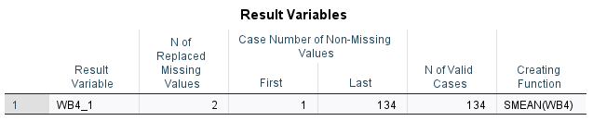

## **Special event prestige (PRE)**

## **Involvement in Special Event (INV)**

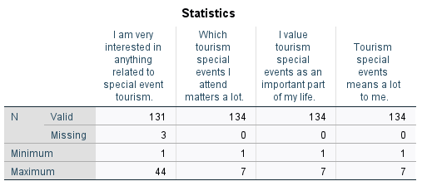

## **Overall experience (EXP)**

## **Word of mouth (WOM)**

## **Social Media Engagement (SM)**

# Preliminary Analysis of Constructs

**Perceived well-being (WB)**

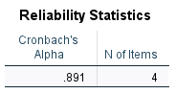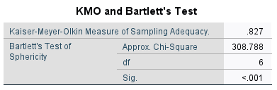

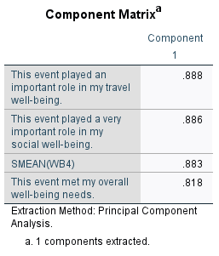

|  |  |  |  |  |  |
| --- | --- | --- | --- | --- | --- |
| **factor loading** | **square factor loading** | **1-square factor loading** |  |  |  |
| **λ** | **λ square** | **ɛ** |  |  |  |
| **0.888** | **0.788544** | **0.211456** |  | **N** | **4** |
| **0.886** | **0.784996** | **0.215004** |  | **AVE** | **0.756** |
| **0.883** | **0.779689** | **0.220311** |  |  |  |
| **0.818** | **0.669124** | **0.330876** |  | **CR** | **0.925** |
|  |  |  |  | **sqrt of AVE** | **0.87** |
| **SUM λ** | **SUM λsquare** | **SUM ɛ (error variance)** |  |  |  |
| **3.475** | **3.022353** | **0.977647** |  |  |  |

**Special event prestige (PRE)**

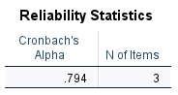

|  |  |  |  |  |  |
| --- | --- | --- | --- | --- | --- |
| **factor loading** | **square factor loading** | **1-square factor loading** |  |  |  |
| **λ** | **λ square** | **ɛ** |  |  |  |
| **0.915** | **0.837225** | **0.162775** |  | **N** | **3** |
| **0.906** | **0.820836** | **0.179164** |  | **AVE** | **0.714** |
| **0.696** | **0.484416** | **0.515584** |  | **CR** | **0.881** |
|  |  |  |  | **sqrt of AVE** | **0.85** |
| **SUM λ** | **SUM λsquare** | **SUM ɛ (error variance)** |  |  |  |
| **2.517** | **2.142477** | **0.857523** |  |  |  |

**Involvement in special event (INV)**

|  |  |  |  |  |  |
| --- | --- | --- | --- | --- | --- |
| **factor loading** | **square factor loading** | **1-square factor loading** |  |  |  |
| **λ** | **λ square** | **ɛ** |  |  |  |
| **0.875** | **0.765625** | **0.234375** |  | **N** | **4** |
| **0.869** | **0.755161** | **0.244839** |  | **AVE** | **0.711** |
| **0.857** | **0.734449** | **0.265551** |  | **CR** | **0.908** |
| **0.768** | **0.589824** | **0.410176** |  |  |  |
|  |  |  |  | **sqrt of AVE** | **0.84** |
| **SUM λ** | **SUM λsquare** | **SUM ɛ (error variance)** |  |  |  |
| **3.369** | **2.845059** | **1.154941** |  |  |  |

**Overall experience (EXP)**

|  |  |  |  |  |  |
| --- | --- | --- | --- | --- | --- |
| **factor loading** | **square factor loading** | **1-square factor loading** |  |  |  |
| **λ** | **λ square** | **ɛ** |  |  |  |
| **0.936** | **0.876096** | **0.123904** |  | **N** | **3** |
| **0.918** | **0.842724** | **0.157276** |  | **AVE** | **0.839** |
| **0.893** | **0.797449** | **0.202551** |  | **CR** | **0.940** |
|  |  |  |  | **sqrt of AVE** | **0.92** |
| **SUM λ** | **SUM λsquare** | **SUM ɛ (error variance)** |  |  |  |
| **2.747** | **2.516269** | **0.483731** |  |  |  |

**Word of mouth (WOM)**

|  |  |  |  |  |  |
| --- | --- | --- | --- | --- | --- |
| **factor loading** | **square factor loading** | **1-square factor loading** |  |  |  |
| **λ** | **λ square** | **ɛ** |  |  |  |
| **0.927** | **0.859329** | **0.140671** |  | **N** | **3** |
| **0.917** | **0.840889** | **0.159111** |  | **AVE** | **0.836** |
| **0.899** | **0.808201** | **0.191799** |  | **CR** | **0.939** |
|  |  |  |  | **sqrt of AVE** | **0.91** |
| **SUM λ** | **SUM λsquare** | **SUM ɛ (error variance)** |  |  |  |
| **2.743** | **2.508419** | **0.491581** |  |  |  |

**Social Media Engagement (SM)**

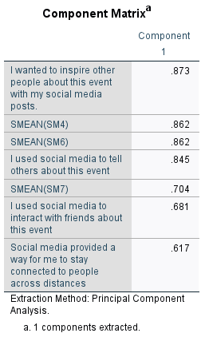

|  |  |  |  |  |  |
| --- | --- | --- | --- | --- | --- |
| **factor loading** | **square factor loading** | **1-square factor loading** |  |  |  |
| **λ** | **λ square** | **ɛ** |  |  |  |
| **0.873** | **0.762129** | **0.237871** |  | **N** | **7** |
| **0.862** | **0.743044** | **0.256956** |  | **AVE** | **0.615** |
| **0.862** | **0.743044** | **0.256956** |  | **CR** | **0.917** |
| **0.845** | **0.714025** | **0.285975** |  | **sqrt of AVE** | **0.78** |
| **0.704** | **0.495616** | **0.504384** |  |  |  |
| **0.681** | **0.463761** | **0.536239** |  |  |  |
| **0.617** | **0.380689** | **0.619311** |  |  |  |
|  |  |  |  |  |  |
| **SUM λ** | **SUM**  **λsquare** | **SUM ɛ (error variance)** |  |  |  |
| **5.444** | **4.302308** | **2.697692** |  |  |  |

# Correlation Analysis of Constructs

# Hypothesis Analysis of Constructs

# Model 1

# 

# Model 2

# Model 3

# 

# 

# Model 4

